RESUME
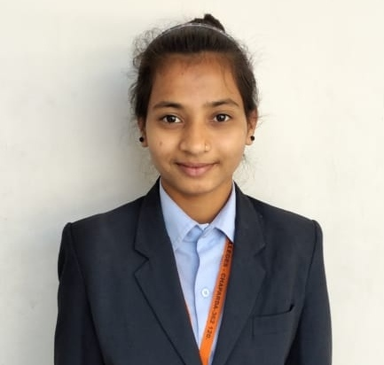
Kamlaben Dodiya
Address:- Chhodavdi near by ramji temple,District-Junagadh,City – Bhesan,
To - Chhodavad (362030)
Email:- kamaladodiya11@gmail.com Call:- 8153811370

To work with a company which appreciates innovation so that I can enhance my knowledge and skills to give my best for the growth of the company.
CAREER OBJECTIVE :
Professional Skills

Intenship in Odoo Developer with 6 month in odoo software development and R&D developmen,401 & 402 ,Floor 4,IT Tower 3 Infocity Gate 1,Gandhinagar,Gujarat 382007
Technical Skills

- Programming Language: Odoo,Python ,Erp , .N`ET,JAVA, WordPress, C, C++.

- Operating systems: windows 7, windows10, Linux.

- Web designing language: HTML, CSS, BOOTSTRAP, JAVASCRIPT.

- Databases: SQL Server, Oracle,MySQL, mongo DB.
Soft Skills

- LeaderShip Stong
- Communication Skill

Project Details

Project: Leave Management System,University Portal,The jewelry shop
Project: Leave Management System
Duration: 5 Month
Role: ‘leave management system use for leave applye for staff and employee’.
Front end: html,css,js
Back end: python,
Project: University portal
Duration: 4 Month
Role: ‘our university portal’ is a website to use manage university’.
Front end: .NET
Back end: SQL SERVER – 2017
Project: The Jewelry Shop
Duration: 3 Month
Role: ‘the jewelry shop’ is a website to online sellingjewelryproduct’.
Front end: PHP
Back end: MySQL

Academic Details

Qualification | Institute | University | Passing Year | Percentage
MCA | Gujarat Vidyapith | GVP | May-2022 | GCPA 6.80
BCA | Shree Brahmanand Institute of Computer  Science,Chaparda. | BKNMU | March-2020 | CGPA 8.1
H.S.C. | Shree Brahmanand  vidhyamandir | G.S.E.B. | March-2017 | 69.58%

Personal Details

FULL NAME : - | Kamlaben kalabhai dodiya
D.O.B : - | 18 march 2000
Gender : - | Female
Nationality : - | Indian
Marital Status : - | Unmarried
Language Known : - | English, Hindi, Gujarati
Hobby : - | Planning for the Projects, Projects Design,

- I hereby declare that all above information are true and best of my knowledge.

Yours faithfully
Kamla K Dodiya

